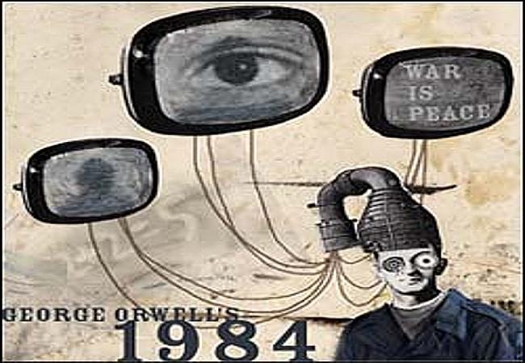
1984 – Section 1: Due 11.19.18
Describe “Big Brother.” Who is this? What does he do?

Name at least 5 ways in which “Big Brother” watches people:

Describe Oceania and the city of London:

The Government of Oceania is divided into four ministries. Name each and describe each division’s purpose. For which one does our main character work, Winston Smith.
-
-
-
-
-

In which ways does the government of Oceania manipulate the past?
-
-
-
-
-

Describe the following terms:
-Speakwrite:

-Telescreen:

-Doublethink:

-Thought Police:

-Thoughtcrime:

-Emmanuel Goldstein:

-The Brotherhood:

-The Party:

-INGSOC:

-Newspeak:

-Memory Holes:

-Facecrime:

Describe the “Two Minutes of Hate.” What purpose does this serve? Why would the government do this and why would they support a “Hate Week”?

In which ways has the First Amendment of the US Constitution been violated throughout this section of thebook?
-Freedom of Speech:

-Freedom of the Press:

-Freedom to Assemble:

-Freedom to Petition:

-Freedom of Religion:

Winston continually talks about how he is “emotionless,” “lonely,” “incapable of expressing himself,” “past feeling,” etc. Why do you think that people in this society, like Winston, have come to this point in their lives.

Describe who would wear the following types of uniforms:
-Blue overalls:

-Black overalls:

-Blue shorts, gray shirts, red neckerchiefs:

-Long black coat and a top hat:

What happened to Winston’s parents? What was the purpose of these “purges”?

Why is the government so active in the lives of the children? What is the purpose of the “Youth League” and the Spies?

What is the purpose behind the idea of creating a new language, Newspeak? Describe the process of how the government is trying to accomplish this task.

Who is Syme? What role does he play for the government? Why does Winston think that he will get vaporized?

Who are the “proles” and why does Winston think that: “If the is hope, it lies in the proles”?

What are the main ideologies of The Party? List four of them and how The Party is trying to accomplish these goals.
-

-
-

-

Why is Winston writing his journal to O’Brien, even though he has never talked with this man?

What is the significance of the following phrase that Winston writes in his journal: “Freedom is the freedom to say that two plus two make four. If that is granted, all else follows”?

What does Winston talk with the old drunk man in the bar? Does this man help Winston fulfill his purposes? Why (not)?

Toward the end of this section of the book, Winston goes into a “junk shop.” What does Winston purchase form the owner, and why does Winston have the thought that he might want to rent the room above the shop?

Describe the following ideologies of The Party, and how The Party uses them to maintain control:
-War is Peace:

-Freedom is Slavery:

-Ignorance is Strength:

